**South Gloucestershire New Local Plan – TRAPP’D Representation**

1. **Introduction and Summary**

I am instructed to respond to this appeal on behalf of TRAPP’D (Thornbury Residents Against Poorly Planned Development). We are an Action Group formed from residents of Thornbury who are alarmed at the impact of the speed and quantum of housing development in and around Thornbury, despite a complete lack of planning for the infrastructure needs of such a growth. We have more than 300 registered supporters.

This current phase of consultation seeks to channel comments towards 18 mostly obscure questions, such as the policy on travelling showpeople, and misses the real issues of substance concerning the development of the Joint Spatial Plan (JSP) into a Local Plan. We therefore submit our response against seven main topic areas where we think the Local Plan as written is unsound. We have restricted our comments to those concerning the overall strategy within the Local Plan, and the detail as it affects Thornbury.

We note that the consultation calls for responses on rural growth in locations such as Tytherington and Olveston, which could also have an impact on services in ‘hub’ towns such as Thornbury. However, we have concluded that we should leave it to those communities to make their own comments about their particular locations, except to say that the overall housing numbers identified in this plan already represents a far higher requirement than the population of South Gloucestershire needs, and therefore any further rural development should be justified solely on the particular local need in those communities, not to play the overall numbers game, or to pander to developers’ desire to build “executive” homes in the countryside.

Finally, we note that in terms of timing South Gloucestershire is running ahead of the other three Local Authorities that are party to the JSP, perhaps mirroring South Gloucestershire’s keenness to overdevelop compared to other Authorities. We would remind the Council that the Local Plan must follow the JSP, which we are intent on opposing in a number of key areas during the examination in public, and it is therefore important that the Local Plan does not get ahead of itself from a process point of view.

1. **South Gloucestershire is volunteering for far more than its share of development**

The document repeatedly refers to “challenges” – as in *“…the Local Plan will respond positively to the challenges facing South Gloucestershire*” (Page 4) – inferring that the 32,500 houses in the plan are, and would always would have been, an inalienable fact which South Gloucestershire is bravely facing up to. This is simply not the case. This number of houses will indeed be a major challenge, but it is one entirely of the Council’s making.

There is no forecast which suggests that South Gloucestershire needs to provide anything like this number. It is entirely the creation of an unbalanced negotiation between the four Local Authorities, with South Gloucestershire performing the role of “Corporal Jones”; volunteering for everything. In this section we review the demand forecasts at Local Authority level and compare that to the plan which South Gloucestershire has acceded to.

At the JSP level the Objectively Assessed Need (OAN) of 97,600 dwellings is intended to reflect the demand from 2016 to 2036. This includes a “market adjustment” factor to reflect the supply / demand situation (15% in the Bath Housing Market Area and 10% in the Bristol HMA), and can be summarised as follows:



The JSP then goes on to propose an overall build of 105,500, the ‘excess’ of 7,900 representing an 8% buffer. However, we can now use this data to compare the South Gloucestershire demand with the proposed build:



This reveals an outrageous 35% (8,500 houses) excess in the South Gloucestershire represented by a demand of 24,000 versus a proposed build commitment of 32,500. This excess is equivalent to almost three Buckovers!

In our JSP comments we point out that the Local Enterprise Partnership (LEP) also commissioned a forecast from Oxford Economics (OE), and this forecast was used in the JSP to assess the need for 79,000 new jobs. However, this forecast also included projections for housing demand that were substantially below the SHMA used above. OE produced 3 scenarios – Baseline (their central scenario), Medium/High and a High version. A comparison of these forecasts with the proposed build is summarised below:



The OE forecast for South Gloucestershire, after ‘market adjustment’ ranges from 18,600 to 22,300 in the highest growth scenario they could come up with, giving an excess in this Authority of between 43% and 31%. Furthermore, OE has given TRAPP’D a statement to the effect that their forecast was produced well before the Brexit vote, at a time when the growth outlook was far more optimistic, and that if they were repeating the exercise today they would be downgrading the forecast substantially.

We accept that Local Authorities have a Duty to Cooperate, which means that the allocation of houses may not follow the pattern of demand exactly. We also reluctantly accept that the allocation finally made within the JSP – once it has been through the examination in public – will be the one that the Local Plan has to accept.

However, there are consequences to this. Not only will we be tearing up more greenfield land than we need to in South Gloucestershire, with all the environmental and other infrastructure consequences this brings, but with a requirement this far above demand, amid a shortage of building labour (now commonly agreed as the main bottleneck to building more houses), this Local Authority is in danger of being in a sub 5 year land supply situation right the way through to 2036. This is turn means that all notions of planned development will go out of the window, with speculative developers making hay by choosing their Greenfield sites according to where the price is best.

We don’t know how or why South Gloucestershire has come to agree to a quantum of houses so far in excess of demand. Is it through a desire to have much more new houses in the Local Authority? Is this simply in order to facilitate Buckover as a vanity project to allow planners the prospect of adding “Garden Villages” to their CVs? Or is it simply that this Authority negotiated poorly?

We don’t know the answer. However, **the Council should come clean in this Local Plan**. The Local Plan has no choice but to take the numbers agreed in the JSP (once they are agreed – not before), but it should tell people how this compares with the demand forecast for the Local Authority and explain its logic about how it arrived at this allocation.

1. **Spatial solutions proposed will worsen the problems identified**

There is a complete disconnect between the issues facing South Gloucestershire and the spatial plan proposed. Simply being able to identify and describe the problems does not that the strategy proposed provides a solution – in this case quite the opposite is true. Key issues identified include:

* Para 1.24: *The substantial levels of new development over the past half century have not been matched by provision of essential physical and social infrastructure. There are issues to do with the quality and quantity of open spaces, sport and recreation facilities in some parts of the area.*
* Para 1.28: *Levels of car ownership and commuting are high and congestion hotspots are a significant problem on strategic and urban roads. Investment in transport infrastructure has been insufficient to provide for the growing economy*
* Para 1.32: *Others are particular issues facing South Gloucestershire and the West of England including addressing congestion,*
* Key issues on page 16: *SGC has experienced high levels of growth and a deficit in the provision of infrastructure to support it. This has resulted in pressure on existing infrastructure which could be exacerbated by proposed new developments.*
* Travel accessibility on page 16: *South Gloucestershire’s position, economic prosperity and historic underinvestment in transport improvements has resulted in:* 
  + *Severe congestion issues affecting economic growth, air quality, public health and quality of life;*
  + *Pressure from new developments on existing transport infrastructure;*
  + *Lack of access to public transport options including to centres of employment from some communities;*
  + *Issues of accessibility from some areas which exacerbates inequality across our communities;*
* Travel accessibility on page 16: *priority for the new Local Plan [is the] …. need to address congestion and accessibility issues through a step change in the quality of our transport infrastructure, with the aim to provide for a programme of significant improvements to walking and cycling, public transport road and rail services, aligned to new development*
* Environment key issues on page 17:
  + *Potential impact of development on landscape, heritage, ecology assets and ecosystems in the context of past levels of growth.*
  + *Preserving and enhancing our valued historic buildings, archaeology, landscapes, ecology, air quality and ecosystems assets;*
* Para 2.7: *locations …. where …. growth might be accommodated so as to achieve the best access to existing or improved transport corridors and support existing or new services and facilities*
* Para 2.18: *High car use and limited public transport options to employment areas and other services are leading to increasing pressure on the transport network and significant problems with community isolation, congestion and poor air quality;*

In other words, there is a recognition that past planning mistakes have been made by focussing on locations that require predominantly car-based travel, with infrastructure not being put in place beforehand, and with large scale Greenfield sites damaging our ecology and environment. Hallelujah!

We can therefore expect a focus in this plan on brownfield locations and smaller smart sites that either minimise the need to travel for work or leisure, or else are already (or could be) served by first class public transport (especially rail) and cycling / walking networks?

No?

What we get is a spatial strategy based around satellite development that creates a large separation between where people will live and where they work, that can only realistically be bridged by the private car. Most new homes will be on large new Greenfield sites. Thornbury will be one of the key development locations, being one of the worst served towns in the Authority for non-car transport, with large greenfield sites around 2km from the town centre, requiring everyone to drive for just about everything.

In particular, the comment under para 2.7 about the selection of areas for growth according to the best access to improved transport corridors is revealed to be a complete sham by our Freedom of Information request on Buckover, whereby the acting head of Transport and Strategic projects said that “*the A38 is still of concern. This is the strategic alternative route for the M5 and at peak times this is an extremely busy route with holiday traffic often backed through the area …. I wouldn’t pursue this on transport grounds alone. But this this could be ‘fudged’ for presentational purposes ….*”(see appendix 1). Astonishingly, policy 7.8 concerning Buckover Garden Village still says nothing more on this topic than words to the effect that a solution will have to be found for this problem.

We reiterate – **this plan is unsound!**

1. **South Gloucestershire should not jump the gun ahead of the JSP**

We have already noted that the South Gloucestershire Local Plan is some way ahead of other West of England authorities in terms of timing and is in danger of being premature given that the JSP has yet to undergo examination in public and will almost certainly not be adopted until towards the end of 2018 at the earliest.

Moreover, there are hints in this draft Local Plan that South Gloucestershire is itching to see some of the largest developments come forward for planning consideration prior to either the JSP or Local Plan being adopted.

We are deeply concerned that this draft contains weasel words to potentially justify individual plans for sites coming forward before adoption of the JSP / Local Plan:

* Para 2.36: *We are also aware that there is already developer interest in some of the locations, and it is important to begin the early thinking about the master-planning of the locations in consultation with local and community interests. This is in order to avoid piecemeal and un-coordinated development that may not deliver the benefits of good place-making and investment in necessary infrastructure. It can also give the council a ‘stronger hand’ in resisting inappropriate proposals in advance of a robust masterplanning process.*
* Para 2.44: *…… where only a single or small number of landowners control a site. In this context, issues can be resolved via a planning application process, and/ or there may be an opportunity to release a part(s) of the SDL earlier than the rest to bring some delivery forward.*

We are aware that in the case of Buckover one of the partners to this potential development has made statements about submitting plans this year, and we suspect the above comments are aimed at justifying such a move. We most strongly object to any move to bring major sites forward ahead of the adoption of both the JSP and the Local Plan, and would remind the Council that where this occurs this should be construed as speculative planning which actively undermines the planning process, and therefore the Council should be actively discouraging this.

1. **The plan will undermine critical climate change commitments**

The Council has an obligation to meet specified CO2 reduction commitments which it will fail to meet if it pursues the proposed spatial strategy.

The South Gloucestershire Annual Monitoring Report (AMR) specifies a 35% CO2 reduction target by 2020 (from a 1990 base) and a 50% reduction by 2025 and 80% by 2050. The 2017 AMR also shows progress to 2015 towards meeting that target:

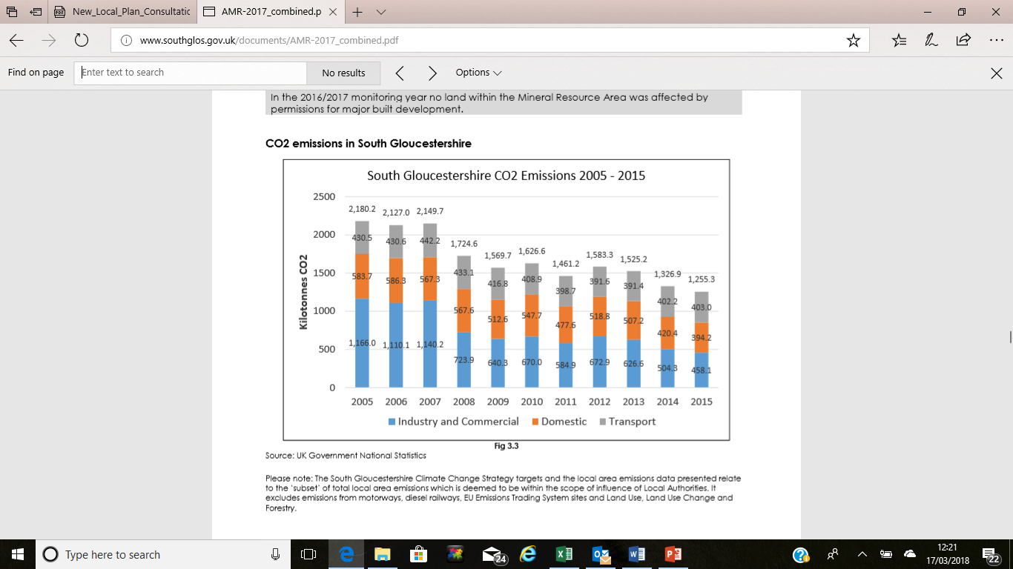

This shows a steady improvement in CO2 levels from Industry and Commerce and from Domestic sources, but a flat performance from transport. This means that transport is becoming increasingly important in the mix:



If we simply project forward current trends to 2025 we will see Transport based emissions approaching 50% of the total CO2 generated:



Therefore, without tackling a reduction in CO2 from transport it can be demonstrated that it will be impossible to meet the specified overall target reductions. Returning to those targets, a 35% reduction by 2020 would mean reducing the overall levels of CO2 to 816kt, and if transport remained flat (despite rising population) then the non-transport elements would have to deliver a 52% reduction. Extending that argument to 2025 and 2050 for the respective targets in those years would require impossible reductions in non-transport levels of CO2 of 74% and 118% respectively:



What this analysis demonstrates is that South Gloucestershire has a duty to reduce transport-based CO2 emissions, which will be a major challenge given the projected increase in population. However, by setting out a spatial strategy that creates a separation between where people live and where they will work it is patently obvious that they will fail to do so.

**It is therefore our assertion that South Gloucestershire is deliberately or recklessly proposing a spatial strategy that will illegally breach target CO2 reductions, and on these grounds alone the plan is unsound**.

1. **South Gloucestershire plays lip service to the need to address infrastructure first**

The Local Plan should be about converting the allocated housing numbers and spatial strategy of the JSP into an executable plan at local level. The Planning Inspectorate guidelines (June 2016) state that “*The plan should focus relentlessly on the critical issues and the strategies to address them, paying careful attention to deliverability and viability. This approach may raise uncomfortable questions but the whole point of the plan is to address the critical issues as far as possible*.” Infrastructure delivery is just such an issue, and this plan fails to address it. We have already quoted the generalisations on this topic in section 3, but there is nothing in this plan about what South Gloucestershire actually proposes to do.

There is nothing tangible in this document about pressure on schools, GP surgeries, and car parking and very little about transport. South Gloucestershire is failing in its duty to set out its strategy to address the challenges posed.

1. **The “One Public Estate” programme should count towards the numbers in the JSP for Thornbury**

We understand that an early example of the “one public estate” programme relates to the proposal to relocate the Castle School 6th form in Thornbury in order to free up additional land for housing development. We will reserve our comments on the specific proposal once the details become clear, but for now we want to ensure that any such scheme would count towards the eventual housing target for the town. Any additional housing in Thornbury, however it is labelled, will contribute towards the challenge the town is facing from the extent and speed of new house development, and by the same token should count towards the overall housing number.

1. **Policy 7.8 (Buckover) and 7.11 (Thornbury)**

Para 2.31 refers to the JSP policies relating to South Gloucestershire, of which policy 7.8 concerns Buckover and 7.11 concerns Thornbury. TRAPP’D have commented in detail on these two policies and we attach a copy of our opposing commentary on these two policies in Appendix 2 and 3.